Elizabeth Hawkins

245-Linux Administration

Continue Setup for Ubuntu

10/31/2021

In this lab there are a couple of things you need to install on your system to get it up and running. I will be installing Tmux, emacs, Fail2ban,cowsay,lolcat, and updating VI to Vim. To install these things on the Ubuntu you will use the Sudo apt-get command to install the programs.

The first application we need to install is Tmux.

Tmux is an open-source terminal multiplexer for Unix-like operating systems. It allows multiple terminal sessions to be accessed simultaneously in a single window. It is useful for running more than on command-line program at the same time.(google.com)

Step 1. To install Tmux on your Ubuntu server you use the command sudo apt-get install tmux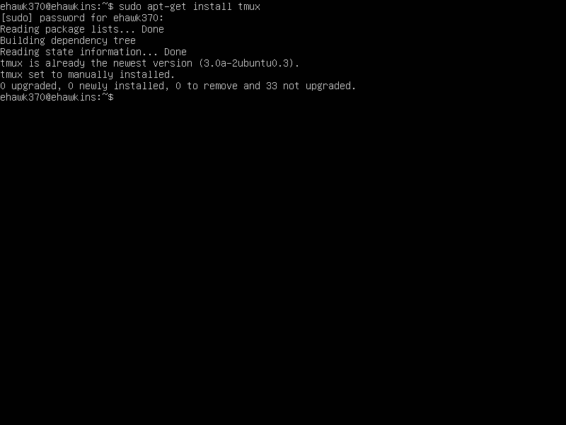

Step 2. Installing Emacs

Emacs is a text editing tool that comes out-of-the-box with Linux and macOS.

To install Emacs you use the command sudo apt-get install emacs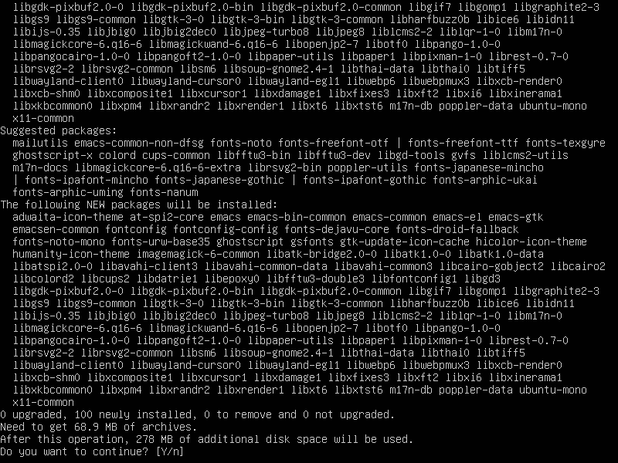After the first operation is finished, it will ask you about the 278 MB of additional disk space will be used and if you want to continue, you press yes, and it will continue. 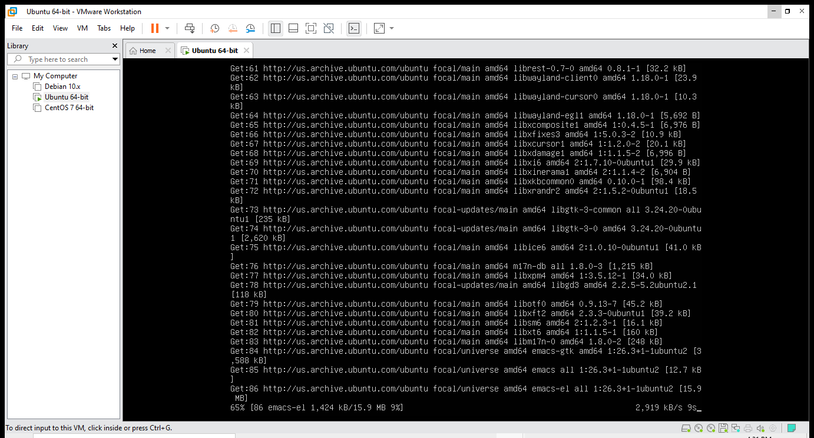

Step 3 Install Fail2ban

Fail2Ban is an intrusion prevention software framework that protects computer servers from brute-force attacks. (Googl.com) This will ban the IP (for a certain time) if there is a certain number of failed login attempts.

To the install fail2ban I ran the command

Sudo apt-get install -y fail2ban

After fail2ban is installed for it to work you need to start and enable the service. To do this you need to run the command

Sudo systemctl start fail2ban

Sudo systemctl enable fail2ban.

The command looks like this after you run it.

The next thing you must do is configuration of a jail for SSH login attempts.

A jail in Linux is a directory tree that you create within your file system, the user is not able to see other directories or even files that can be located outside the jail directory.

To run this, you use the command sudo nano etc/fail2ban/jail.local:  to store all the information of your fail2ban.

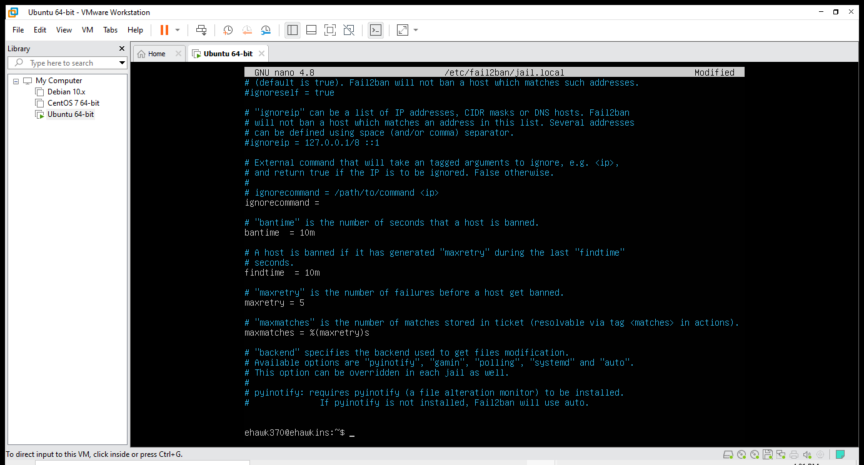

Maxretry = 5 Maximum login attempts

Findtime = 10m Maximum 5 login attempts in the time span of 10 minutes

Bantime = 10m Maximum jail or ban for 10 minutes after 5 invalid login attempts.

Step 4 Install Cowsay

Cowsay is a program that generates ASCII art pictures of a cow with a message.(Google.com)

To install Cowsay you run the command sudo apt-get install cowsay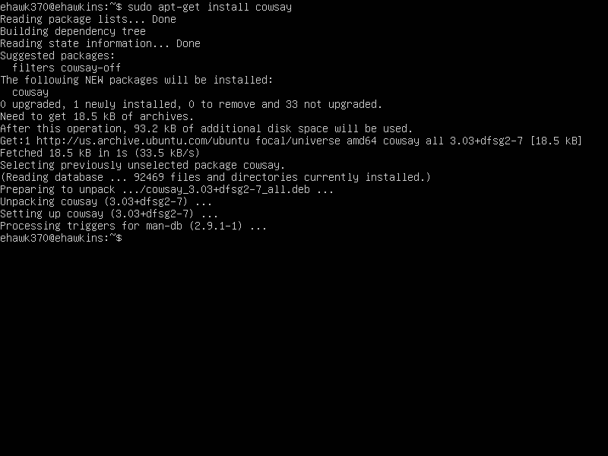

To see Cowsay works you run the command cowsay test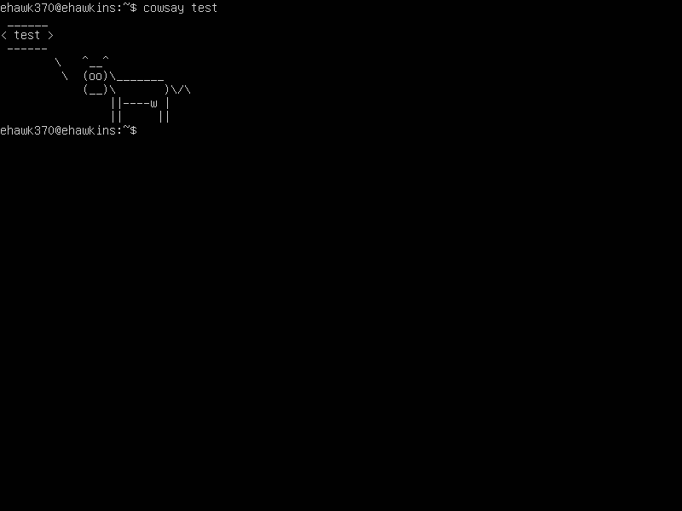

To check the location of where Cowsay is installed you run the command which cowsay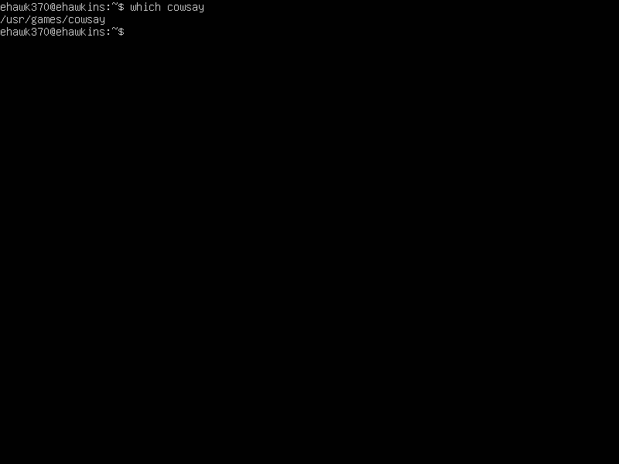

Step 5 Install Lolcat

Lolcat is a utility for Linux, BSD and OSX which concatenates like similar to cat command and it will allow you to have colors on it.

To install lolcat you use the command sudo apt-get install lolcat

After you install lolcat it tells you 32.9MB of additional space would be used to continue press yes and continue the installation.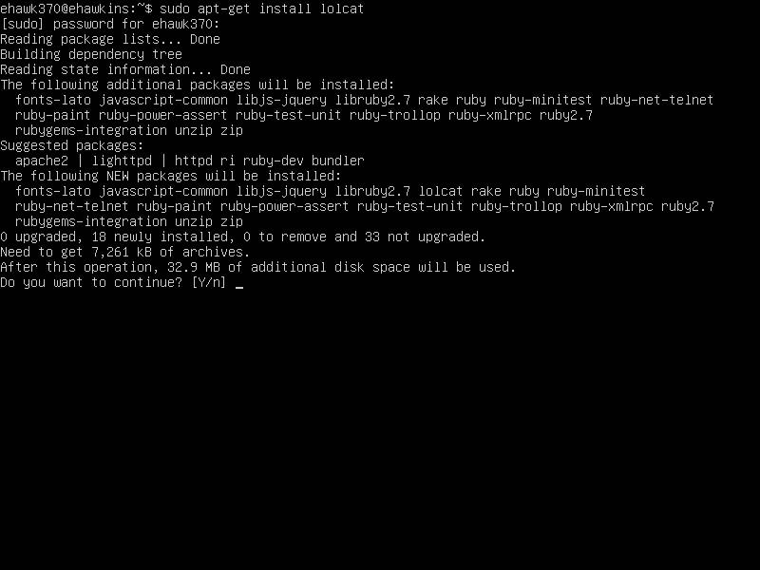

To see is lolcat is working you need to type what the cow would say and pipe it to lolcat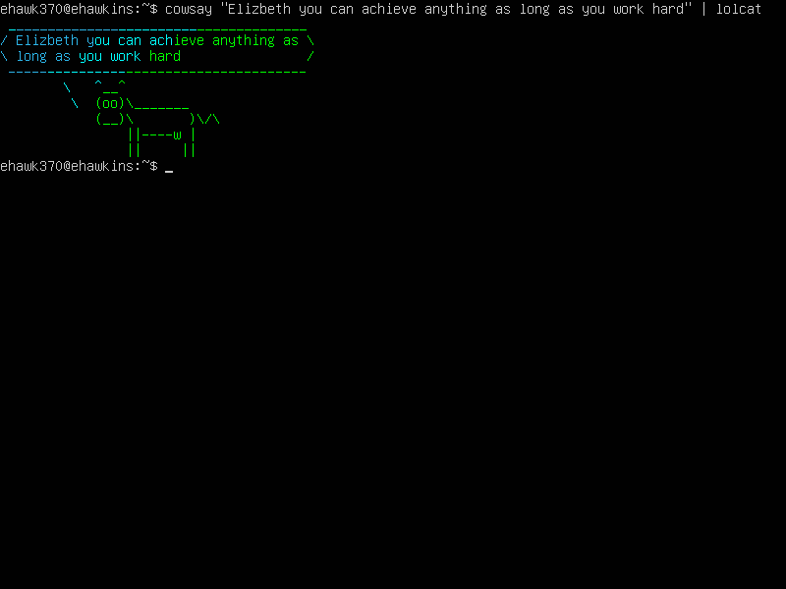

Step 6

Update Vi to Vim

For me to update VI to Vim we are going to use the same commands for installation. To install Vim you use the command sudo apt-get install vim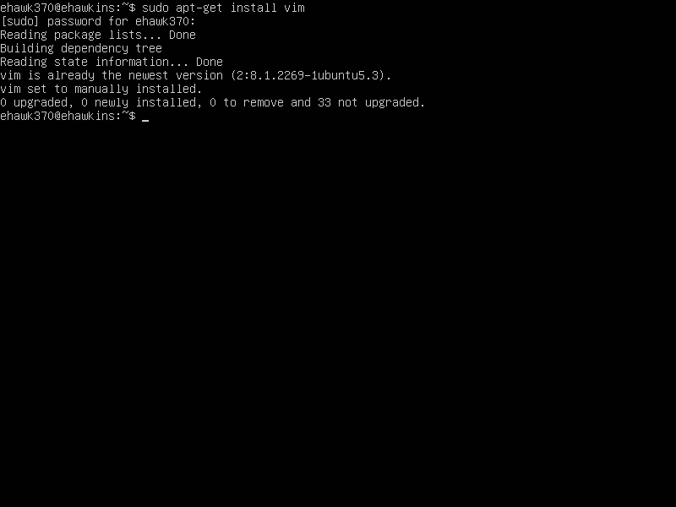

To check if the update is working properly, you will check the script using both VI and VIM and if comes out with the same it is working properly.

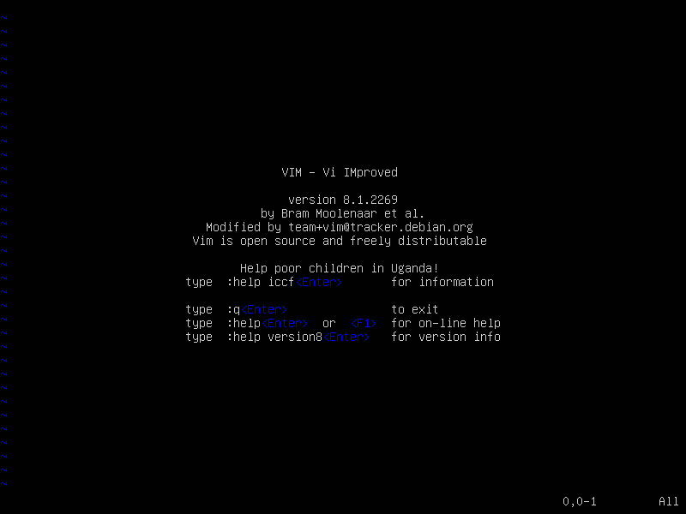

To update your server if needed you need to run the command sudo apt-get update; sudo apt-get upgrade.

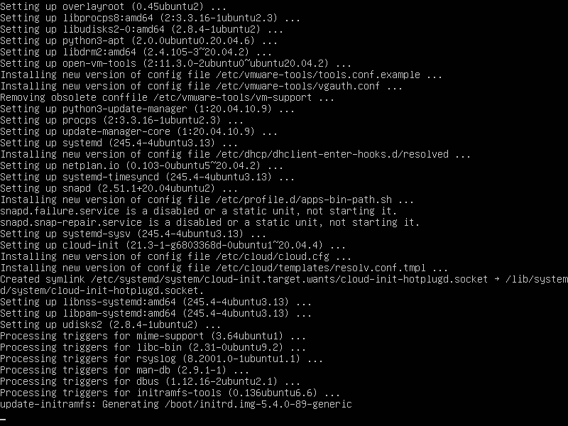

To find the location of the programs you already installed and where can be found we are going to use the which command.

Which command is used to locate the executable file associated with the given command. 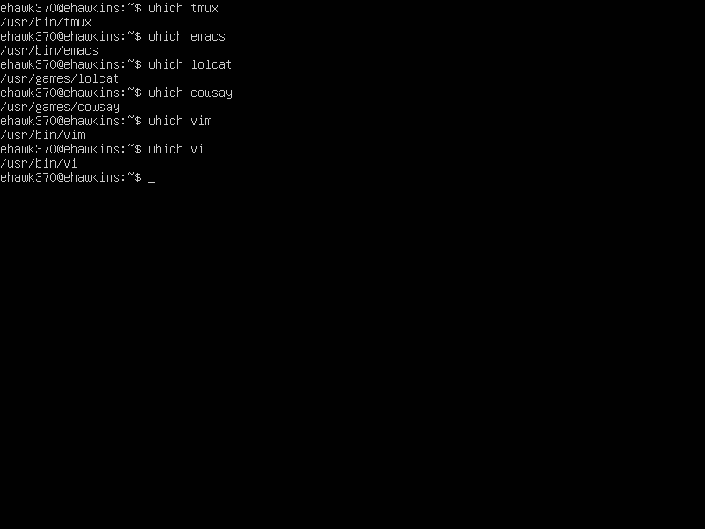

To see the files, we can use the dpkg.log this helps provide when packages have been installed and when.

grep installed /var/log/dpkg.log: using grep you will search for a global regular expression print and as we want the packages that were installed you will add the packages you are looking for.

grep installed /var/log/dpkg.log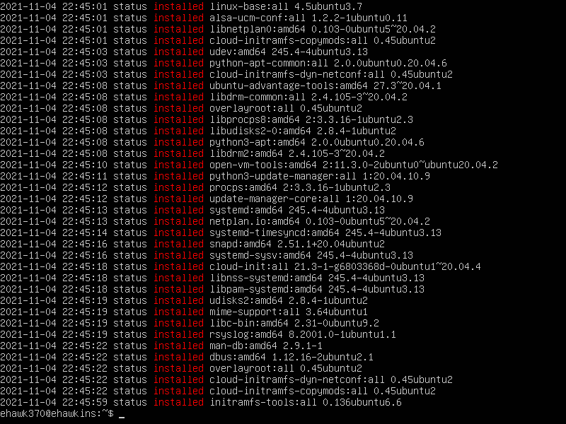

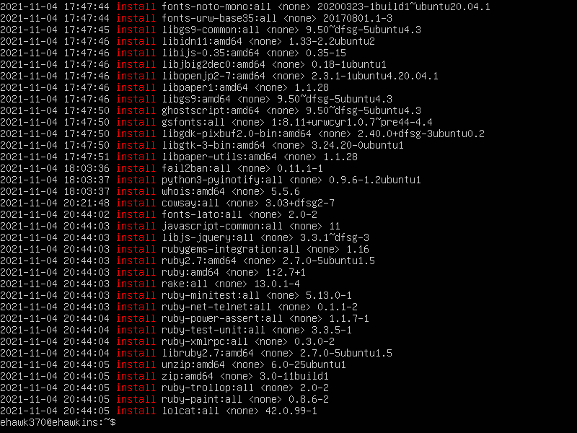

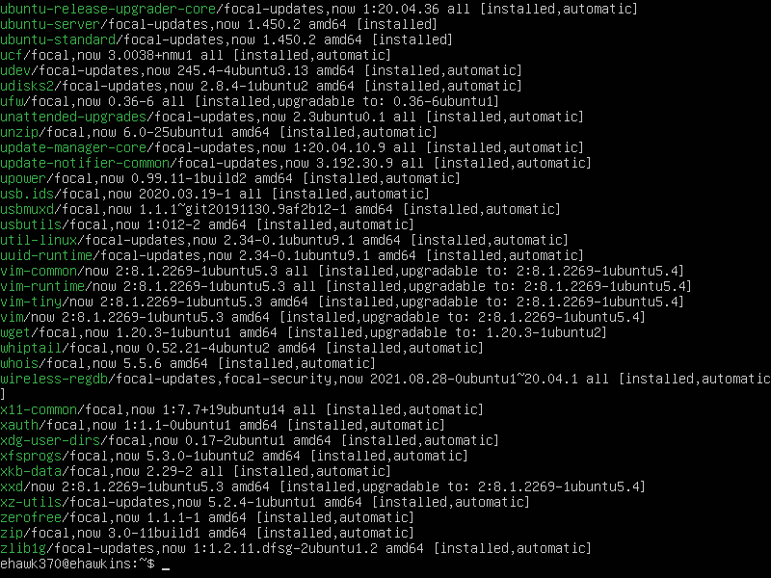

Adding a repository

You can also configure the packages to add or remove a personal archive (PPA)

For you to do this you have to run the command sudo apt-add-repository ppa:ansible/ansible this command will add a repository.

To remove a repository you use the commad sudo apt-add-repsoitory –remove ppa:ansible/ansible

